8.1 Enthalpy change
Name: ____________________ Class: ____________________ Due date:
1. The diagrams show the difference in energies of the reactants and products in two types of reaction. 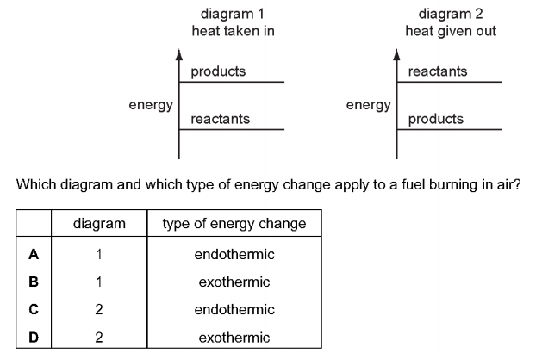
Which diagram and which type of energy change apply to a fuel burning in air? （ ）

2. The diagram shows a match
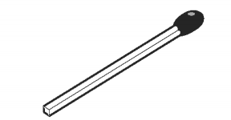
By striking the match, a chemical reaction takes place.
Which statements about the chemical reaction are correct? （ ）
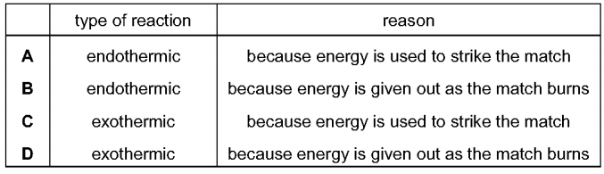

3. When anhydrous copper(ll) sulfate is added to water a solution is formed and heat is given out.
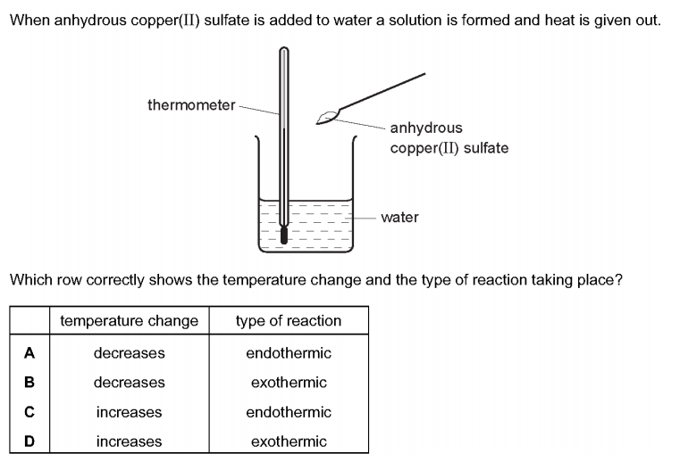
Which row correctly shows the temperature change and the type of reaction taking place? （ ）

4. When ammonium nitrate is added to water the temperature of the water decreases. The ammonium nitrate can be recovered by evaporating the water added.
Which explains these observations? （ ）
A The ammonium nitrate dissolves in the water and the process is endothermic.
B The ammonium nitrate reacts with the water and the process is endothermic.
C The ammonium nitrate dissolves in the water and the process is exothermic.
D The ammonium nitrate reacts with the water and the process is exothermic.

5. Solutions of two chemicals are mixed.
A reaction occurs and the temperature change is measured.
Which statement is correct? （ ）
A If the reaction is endothermic, the temperature decreases and energy is taken in.
B If the reaction is endothermic, the temperature increases and energy is given out.
C If the reaction is exothermic, the temperature decreases and energy is given out.
D If the reaction is exothermic, the temperature increases and energy is taken in.

6. Some reactions are endothermic
How does the temperature and energy change in an endothermic reaction? （ ）
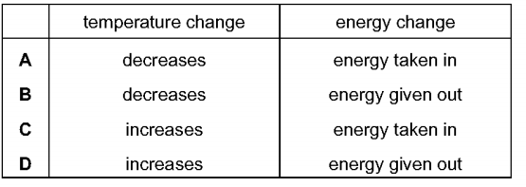
7. Which statements about exothermic and endothermic reactions are correct? （ ）
1 During an exothermic reaction, heat is given out.
2 The temperature of an endothermic reaction goes up because heat is taken in.
3 Burning methane in the air is an exothermic reaction.
A 1, 2 and 3 B 1 and 2 only C 1 and 3 only D 2 and 3 only

8. The elements hydrogen and uranium are used as fuels.
The compound ethanol is also used as a fuel.
Which fuels require oxygen in order to produce heat energy? （ ）
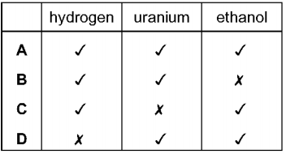
9. Which experiment is the most exothermic? （ ）
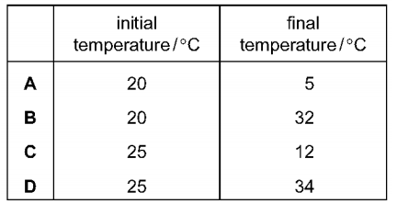
10. Some properties of four fuels are shown in the table.
Which fuel is a gas at room temperature and makes two products when it burns in a plentiful supply of air?
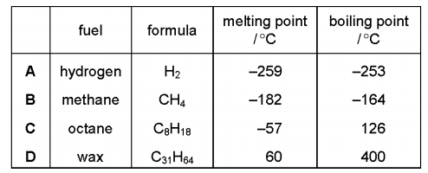
11. Which statements about endothermic reactions are correct? （ ）
1 The energy of the products is greater than the energy of the reactants.
2 The energy of the reactants is greater than the energy of the products.
3 The temperature of the surroundings increases during the reaction.
4 The temperature of the surroundings decreases during the reaction.
A 1 and 3 only
B 1 and 4 only
C 2 and 3 only
D 2 and 4 only
12. The temperature of the water in two beakers, X and Y, is measured as 21.5 °C.
5 g of sodium chloride is dissolved in the water in beaker X. The temperature changes to 18.0 °C.
5 g of calcium oxide is dissolved in the water in beaker Y. The temperature changes to 29.4 °C.
Which types of process are occurring in beakers X and Y? （ ）
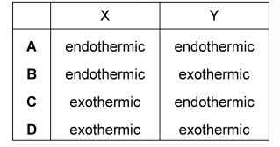
13. A diagram for the energy change during an exothermic reaction is shown.
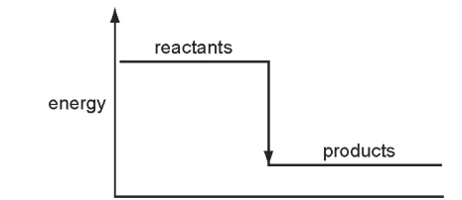
For which reactions would this be an appropriate diagram? （ ）
1. CH₄ + 2O₂ → 2H₂O
2. 2H₂ + O₂ → 2H₂O
3. C + O₂ → CO₂
A none of them B 1 and 2 only C 2 and 3 only D all of them

